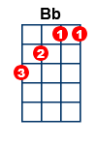
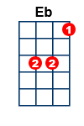
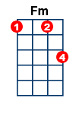
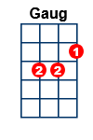
Blue Moon [100] [C] gg fgaggfg (Ray)
Elle Fitzgerald

Intro: [C] . . [Am] . . [Dm] . . [G7] . . [C] . . [Am] . . [Dm] . .
[G7] . Blue
[C] moon . [Am] . . [Dm] . You saw me [G7] standing a-
[C]-lone . [Am] . . [Dm] . Without a [G7] dream in my
[C] heart . [Am] . . [Dm] . Without a [G7] love of my
[C] own . [Am] . . [Dm] . . [G7] . Blue
[C] moon . [Am] . . [Dm] . You knew just [G7] what I was
[C] there for . [Am] . . [Dm] . You heard me [G7] saying a
[C] prayer for . [Am] . . [Dm] . Someone I [G7] could really
[C] care for . [Am] . .
[C] . . [C7] . And then there [Dm] suddenly ap-[G]-peared be-
[C]- fore me [Am] The only [Dm] one my arms would [G] ev-er
[C] hold . [C] . I heard some-[Fm]-bo-dy whisper [Bb] . please a-
[Eb]dore me [Eb] . And when I [G] looked The moon had [D] turned to
[G] gold . [G7] . Blue
[C] moon . [Am] . . [Dm] . Now I’m no [G7] longer a-
[C]-lone . [Am] . . [Dm] . Without a [G7] dream in my
[C] heart . [Am] . . [Dm] .Without a [G7] love of my
[C] own . [Am] . .
[C] . . [C7] . And then there [Dm] suddenly ap-[G]-peared be-
[C]- fore me [Am] The only [Dm] one my arms would [G] ev-er
[C] hold . [C] . I heard some-[Fm]-bo-dy whisper [Bb] . please a-
[Eb]dore me [Eb] . And when I [G] looked The moon had [D] turned to
[G] gold . [G7]. .
[G7] . Blue
[C] moon . [Am] . . [Dm] . Now I’m no [G7] longer a-
[C]-lone . [Am] . . [Dm] . Without a [G7] dream in my
[C] heart . [Am] . . [Dm] .Without a [G7] love of my
[C] own . [Am] . .
<Slow single strums>[Am] <Single strum>[C]

